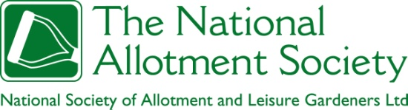
National Allotments Week 2026
Participant’s Grow to Learn Publicity Guide

Thank you for registering for National Allotments Week 2026: Grow to Learn. Please find enclosed information we feel may be helpful to you, including a template press release, tips on how to publicise your event and a health and safety risk assessment template.
Included in this pack is:
- Background information
- Why Allotments and wellbeing?
- Allotments and wellbeing event ideas
- Guide on how to gain publicity
- Press Release Template
- Model Release form for Photographs
- Risk assessment Template
- Quiz Questions Template
- Poster Templates
- Social Media Templates
- Banner Templates
Please note there will also be a Press Pack available for journalists if this wish to download it at Media & Advertising | The National Allotment Society
What is National Allotments Week?
Started in 2002, National Allotments Week is an initiative which runs annually to help raise awareness of allotments and the role they play in helping people to live healthier lifestyles, grow their own food, develop friendships and bolster communities. Our annual awareness week will run this year from the 10-16 August 2025, and we have chosen a theme of “Grow to Learn”
Why Grow to Learn?
By opening up your allotment site and inviting the local community to see what happens behind the gates, our hope is that more people will begin to see the benefits allotments bring and support us in our efforts to protect existing sites. Allotments not only benefit those who garden the plots, from families and school children through to working couples and retired individuals, but also the wildlife who in inhabit them and the cities that breathe a little easier because of them.
Allotments need protecting from development plans and budget cuts, so now is the time to act. If you think your site is under threat, then there are several things you can do.
- Find out if your land is statutory allotment land or temporary land. If it is statutory land, then the Council must apply to the Secretary of State in order to dispose of your allotments. This process means you have a chance of saving the land by putting together a strong case for its protection. New guidelines from the DCLG(available on our website) advise that consultation with the National Allotment Society is likely to be more constructive when it is done at the point disposal is being considered as an option, as the National Allotment Society can advise on a number of matters including possible alternatives.
- Make sure that allotments are considered in your Local or Neighbourhood Plan.
- Get your site registered as a Community Asset under the Government’s ‘Right to Bid’ scheme, meaning if the land comes up for sale, you (or your association) have six months in which to buy it. http://mycommunityrights.org.uk
- Hold a ‘Grow to Learn’ event to galvanise community support for the site. Show people why the allotment should be kept and ask them to support you.
By throwing a Grow to Learn event we can show even more people how valuable allotments are, and why they must be protected from developers – while at the same time having a great time.
Did you know?
If managed and worked effectively an allotment can produce hundreds of pounds worth of produce a year – just think, fewer supermarket trips, less air miles and a happier tummy! Alongside this, allotments provide habitats for wildlife and help to keep cities breathing. If added together, all the UKs allotments would equal 58 Hyde Parks! This is a vast amount of land that is cared for, enjoyed by hundreds of thousands, and a real benefit to the communities which surround them.
Allotments and Learning Event ideas
Grow to Know celebrates how allotments help people learn and grow in many different ways. This year, we’re focusing on learning through physical activity, mental wellbeing, social connection, and nutrition — all rooted in the simple act of growing food. Below are some ideas to bring the theme to life:
- Grow to Know Baking Challenge
Host a friendly baking competition focused on the healthiest cake or bake using allotment produce. Invite the local community to take part and share recipes, skills, and knowledge.
- Community Cooking Event
Show how food grows into meals by holding a cooking demonstration using allotment produce. Ideas include BBQ corn, vegetable kebabs, stir-fries, jams, and sauces — anything that can be cooked on a BBQ or temporary stove.
- Gardening, Learning & Wellbeing Talk
Arrange a talk exploring how growing helps us learn about ourselves — from herbs that encourage relaxation to personal stories of how gardening has supported mental health. You could even include a yoga or mindfulness session on the plot.
- Grow to Know Fitness Fun Day
Celebrate the physical side of growing with a fun fitness event: welly throwing, potato digging, compost turning, and more. A great way to show that allotments keep us active — and have a laugh while doing it.
- Allotment-Themed Fundraising Quiz
Host a quiz night in your village hall or allotment building. Invite the wider community to test their knowledge, with prizes such as homemade produce, vegetables, or simply bragging rights.
- Creative Grow to Know Craft Competition
Encourage creativity by asking participants to make something that represents allotments and learning. From crocheted cabbages and knitted carrots to school collages, finish with a small exhibition and awards ceremony.
- Grow to Know Open Day
Open your allotment to visitors and share what you’ve learned. Offer guided tours, answer questions, and, if possible, end with homemade carrot cake and elderflower cordial for a warm welcome.
- Art & Nature Project
Invite a local artist or school to create an allotment-inspired feature to be unveiled during National Allotments Week — perhaps a flowerpot sculpture, decorative bird deterrent, or community artwork.
- Ask the Expert Table
Set up an “Ask the Expert” stall at school fetes, open days, or local events. A great way to share growing knowledge, tips, and encouragement with new and aspiring growers.
- Grow to Know Vegetable Auction
Ask allotmenteers to donate produce to auction at your event. It’s a fun way to raise funds, celebrate the harvest, and share the value of growing food locally.

Publicity
Contacting the local press
Publicity is a vital tool in attracting people to your Grow to Learn Plot event. Publicity can take many guises, including putting up posters, word of mouth, social media and engaging the local press.
Included in this pack is a template press release which you can base your own release on and send to your local newspaper, radio station or evening news programme.
A press release is, in essence, a one stop information sheet for journalists. It should include the who, what, where, when and why of the event, a printable quote, contact details and if possible should be sent with a high resolution photo, attached as a JPEG (300dpi/1MB in size).
Once you have your press release written and ready it should be sent via email to the news desk of your local paper/magazine or the forward-planning desk of any radio or TV programme you wish to be featured on.
You can find the contact details for the relevant reporter by looking in the contents pages of the newspaper/magazine, in the ‘contact us’ section of the publication’s website (search via google), or by calling the switchboard of your local radio or TV station.
It is best to send the release a week before the event and then follow up with a phone call a day or two later. You can always invite a journalist or photographer down to cover the event, but please don’t be despondent if they don’t turn up as staffing to cover events is less than it used to be.
Once the event has taken place remember to send in any photos of the day along with another press release explaining how well the day went and what was achieved.

What makes a good photo?
The old adage is true – a picture tells a thousand words. But in order to get an image printed it must be interesting. It is much easier to take all your images digitally, as picture desks will rarely accept anything other than an electronic image these days. Please remember to set your camera to the highest resolution setting possible.
The best images are those with a centralised focal point which have been staged to support the message of the story you’re trying to tell. Where possible the photographer should take the photo from an interesting angle e.g., looking up or down at the subject matter.
Please always seek permission of the people you are photographing. If your shots are of individuals then ask them to sign a form stating that they understand the pictures are for publicity purposes (If you are photographing children, please talk to the parents). A Model Release Form is included in this pack. To cover crowd shots, it is best to display a sign saying ‘photographic equipment is being used throughout the event and if anyone should wish to opt out of having their image used for publicity purposes, then please see the event organiser.’
If you have not taken the photo yourself, you must get permission from the photographer to use the picture, as he or she will own the copyright on that image.
Newspapers and magazines will also ask for the names of the people in any shots they are going to print, so please do remember to collect these details when asking for permission.
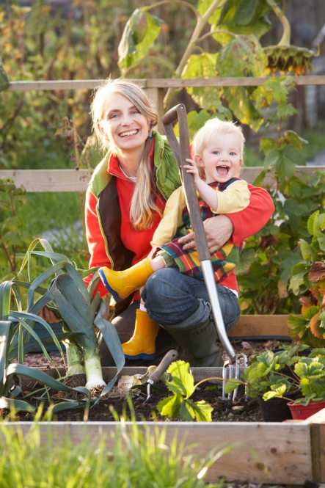
Example of a good press image – (staged image)
The photographer and subject matter are crouched down, giving the image an interesting angle and tight focal point.
The image in not overcrowded, it offers a clear message to the reader that the story is about the mum and daughter gardening.
The child is animated and smiling, and both subjects are looking at the camera. The colours are strong, and it is clear they are gardening/in an allotment thanks to the ‘props’

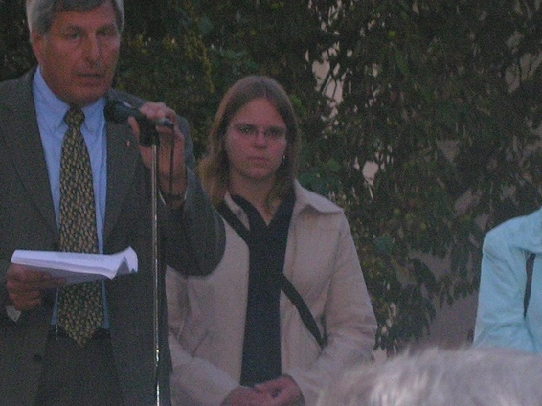
Example of a bad press image – (snapshot)
The photographer has not framed the subject matter in the centre of the image – instead he is off to the left, not looking at the camera and mid- way through a sentence.
The image is too dark and the quality too grainy.
The image does not tell a story, and the location is not easily identifiable from the photo.

Posters
We have purposefully left a space so you can fill in the details of your own event. We can also email you a pdf of the poster so that you can print out extra yourself.
We would recommend these be placed on local notice boards, in libraries, on the gates to the allotment site and in the windows of nearby shops.
The National Allotment Society website – www.thenas.org.uk
All of the events registered for National Allotments Week will be publicised on www.thenas.org.uk If you haven’t yet informed the team what your event will comprise of, please email marketing@thenas.org.uk with the following details
- Name of Society
- Address/location of Wellness on the Plot
- Date of event
- Time of event
- Entry fee
- Activities on the day plus any local VIPs/celebrities attending
- Contact person plus phone number and email address

Other publicity ideas
- Flyers – through people’s doors inviting them to a Wellness on the Plot event. Remember to include the who, what, where, when and why of the event – plus a contact number for more information
- Social media – Instagram and Facebook. If any of your members use these social media networks then please ask them to tweet regularly or post comments every couple of days about the forthcoming event. If posting yourself please use the following hashtags #Nationalallotmentsweek, #Nationalallotmentsweek26, and #Allotmentsandwellbeing #Naw26and remember to tag us :
- Facebook: @Nationalallotmentsociety
- Instagram: @national_allotment_society
- Schools and community groups – write a letter or send a party invitation to your local groups, but please make sure your event is suitable for whoever you invite.
- Local dignitaries/celebrities – write and invite them to open your event or be guest of honour. Their name could help to attract further publicity or guests.
- Freebies and competitions – everybody loves a freebie, so why not incentivise your event by offering the first 50 people through the gates a free afternoon tea or run a competition where the 100th person through the gates wins a weekly vegetable box for summer. Remember to tell any publication/journalist about your competitions for extra publicity.
Health and Safety
Please ensure you inform your landlord about your intention to hold an event on site. Most will be in favour of the idea, but they will ask if you have completed a health and safety questionnaire or risk assessment. Much of health and safety is common sense, but you need to prove you have done the thinking to appease most landlords.
Attached to this document is a template risk assessment. Please do use this if your landlord is unable to provide you with their version.

Insurance
As an allotment society you should already have insurance which covers public liability, but please do check your policy.


Template Press Release

Press Release: ? August 2026(the date you are sending the release out)

Local residents invited to ‘Grow to Learn’
to mark National Allotments Week 2026

Northfields Allotment Association, located just off Rowland Road in Evington, Leicester, has joined forces with The National Allotment Society to host a ‘Grow to Learn’ event to mark National Allotments Week 2026 (10-16 August).
The local association, which has over 100 members, is inviting residents and community groups across Evington, to come and join their party on Saturday 16th August 2026, between 11.30am and 5pm.
This year’s National Allotments Week, as organised by The National Allotment Society is themed around “Grow to Learn” celebrating the inclusive nature of allotments, with people from all walks of life, cultures and abilities enjoying growing their own food. It is also an opportune time to highlight the fact that we need to protect our sites for future generations to enjoy.
Trevor Jones, Site Secretary for Northfields Allotment Association, said, “We really hope our Party will be a huge draw for the local residents, as we want to show how brilliant allotments are and encourage people to see the value in having them on their doorstep. “
“We’re going to have local food stalls, cookery demonstrations with some of the food we’ve grown, gardening demonstrations, a brew-your-own tent and lots of activities for the kids. The Party is free and starts at 11.30am until 5.30pm.”
Charlotte Watts, PR and Marketing Officer for the National Allotment Society, said, "This year, National Allotment Week celebrates the knowledge people attain from being on an allotment, this can be practical skills of growing fruit and vegetables, to mental and physical wellbeing, life lessons such as patience and resilience, and the social connections that come from growing alongside others. We urge everyone who values these benefits to reach out to their local council and advocate for the inclusion of allotments in Local Plans and other key policies. If a site faces potential disposal, the Planning Casework Unit will evaluate any contradictions with council policies, especially those supporting community well-being in local or neighbourhood plans. “To find out more about Northfields Allotment Association’s Wellness on the Plot please call Trevor Jones on 07966548712 or email T.jones@gmail.com
-Ends-

Notes to Editors
For media enquires call Kathy Midds, Publicity Officer for Northfields Allotment Association on 01162 548 96542 or email kathymidds@hotmail.co.uk

About the event
Northfield Allotment Association’s Party on the Plot will take place on Saturday 9th August 2026. Entry is free and the event will start at 11.30am, ending at 5pm. The allotment site is located just off Rowland Road in Evington, Leicester (opposite houses number 45 and 47).
About Northfields Allotment Association
Northfields Allotment Association was formed back in 1978. The site, comprising of 90 plots, is owned by Leicester Council and is deemed statutory land. It has a strong membership base of over 100 members who enjoy growing fruit, vegetables and flowers. The site also lets land to the local primary school, St Joseph’s, which has an active kids gardening club. For more information see www.nfaa.org.uk
About ‘Allotments and Learning”
National Allotments Week is a time to celebrate everything that makes allotments special. Set up by The National Allotment Society over two decades ago, it’s aim is to raise awareness of how these havens bring benefits to individuals, communities, and the planet. From growing your food, to connecting with others and enjoying the fresh air, allotments are at the heart of wellbeing.
This year’s theme, Grow to Learn, emphasises how allotments help teach so many valuable lessons , from life lessons of patience and resilience to practical lesson on hoe to grow health produce.
It’s also a great time to remind everyone how important it is to protect these precious spaces. As our towns and cities grow, allotments need our support to keep thriving as places for people and wildlife alike for generations to come.
The National Allotment Society is hoping these National Allotment Week events will encourage local communities to see the benefits of allotments and take steps to help to protect them in the future. For more details see www.thenas.org.uk
About the National Allotment Society
The National Allotment Society is the working title of the National Society of Allotment and Leisure Gardeners Limited (NSALG). This name was adopted in June 2012 to help people identify more easily with the work of the Society.

The National Allotment Society is the only national organisation which campaigns for the rights of allotment holders across the UK; protecting, promoting and preserving allotments for all. It is a not-for-profit organisation that provides free legal advice, a bespoke benefits package and the services of a regional representative to its members. To find out more visit www.thenas.org.uk For PR and media enquiries relating to The National Allotment Society contact Marketing@thenas.org.uk

Model Release Form

I hereby give permission for my image/my child’s image*, as taken at Wellness on the Plot, on [insert date] located at [insert address] to be used for general publicity purposes in relation to the event and promotion of [insert allotment association’s name] and The National Allotment Society. I do not expect remuneration of any kind.

Signed

Print name

Address

Email/phone

Date

Age

Name of child
Age of child
School attended by child (if applicable)

*delete as appropriate

For Office Use

Description of person in the photograph:

Risk Assessment Template (see below for a filled-in example)

Event

Location

Hazard  (something with the potential to cause harm) | What could go wrong? | Who may be harmed? | What can be done to help control the risk? | Will the risk still be high, medium or low once actioned? | What extra controls need to be put in place? | Date actioned? | By whom?

Example Risk Assessment

Event: Party on the Plot (National Allotments Week 2014) Date: 8th August 2026 Time of Event: 2pm – 6pm Location: St Anne’s Allotments, Liverpool Rd, L16 2DN Health and Safety Contact: Dave Brown, Site Manager - 077965842547

Hazard  (something with the potential to cause harm) | What could go wrong? | Who may be harmed? | What can been done to help control the risk? | Will the risk still be high, medium or low once actioned? | What extra controls need to be put in place? | Date actioned? | By whom?
Uneven path surface on the allotment | People could trip and injure themselves | Visitors to Party on the Plot | Warning signs will be posted on the site and coloured tape placed on trip hazards | Medium – as the surface cannot be replaced | Stewards will make people aware of the uneven surface as they enter the Party | 4th August 2012 & 8th August 2025 | Dave Brown as site manager and Karen, Vince and Shirley as Stewards

M

National Allotment Week Quiz – Example
Theme: Learn to Grow on the Allotment
- What year was the first UK allotment law introduced?
a) 1720
b) 1809
c) 1908
(Answer: c) 1908)
- How many square metres are there in a standard UK allotment plot?
a) 125
b) 250
c) 500
(Answer: b) 250)
- Which famous physicist once owned a neglected allotment in Berlin?
(Answer: Albert Einstein)
- What is the most commonly grown vegetable on UK allotments?
(Answer: Potatoes)
- True or False: Rhubarb is technically a vegetable, not a fruit.
(Answer: True)
- Which fruit shares its name with a bird?
(Answer: Kiwi)
- Gardening is considered light exercise. On average, how many calories can you burn in an hour of gardening?
a) 150–200
b) 300–400
c) 500–600
(Answer: b) 300–400)
- Which vitamin is most commonly associated with spending time outdoors on your allotment?
(Answer: Vitamin D)
- Name one way gardening helps us learn to support our mental wellbeing.
(Sample answer: reduces stress, improves mood, builds confidence, provides a sense of achievement.)
- Which former Labour Party leader is known for making jam from his allotment produce?
(Answer: Jeremy Corbyn)
- What is the theme of this year’s National Allotment Week?
(Answer: Learn to Grow)
- What is the official term for a fear of vegetables?
a) Lachanophobia
b) Vegophobia
c) Herbophobia
(Answer: a) Lachanophobia)
- If you plant this vegetable upside down, it can still grow perfectly well. Which one is it?
a) Carrot
b) Potato
c) Onion
(Answer: b) Potato)
- Which famous children’s character loves to “borrow” vegetables from Mr McGregor’s garden?
(Answer: Peter Rabbit)
- What unusual gardening method involves growing plants in straw bales instead of soil?
(Answer: Straw bale gardening)
- When practising companion planting, which flower is commonly grown alongside vegetables to deter pests such as aphids?
a) Sunflowers
b) Marigolds
c) Daisies
(Answer: b) Marigolds)
- Which vegetable was once used as currency in ancient Egypt?
a) Onion
b) Garlic
c) Cucumber
(Answer: b) Garlic)
- What quirky nickname is often given to oversized courgettes grown on allotments?
a) Courgette Colossus
b) Marrow Monster
c) Zucchini Zeppelin
(Answer: c) Zucchini Zeppelin)
- What unusual gardening competition involves growing the heaviest version of this vegetable?
(Answer: Pumpkins)
- Which vegetable was the first to be grown in space?
a) Potato
b) Lettuce
c) Radish
(Answer: b) Lettuce)

